**Mini Project**

on

**“Non-Contact AC Voltage Detector”**

For the partially fulfilment of the

Degree of Bachelor of Technology

In

Electronics & Communication Engineering



**Submitted by: -**

Name: -Aviral Srivastava

University Roll no.:-(2100540310008)

**Submitted to: -**

**Department of Electronics and Communication**

Babu Banarasi Das Institute of Technology and Management, Lucknow

Session 2022-2023

**Declaration**

I hereby declare that the Mini Project Report entitled ("Non-contact AC voltage detector") is an authentic record of my own work as requirements of Industrial Training during the period from _______ to_______ for the award of degree of B.Tech. Electronics and Communication engineering), Babu Banarasi Das National Institute of Technology and Management, Lucknow.

**Date: ____________________ Aviral Srivastava**

(2100540310008)

**ACKNOWLEDGEMENT**

We feel great pleasure to acknowledge all those involved in the process of our education and research and to remind the fine people in the Engineering works for their sincere guidance. We have taken efforts in this project. However, it would not have been possible without the kind support and help of many individuals and organizations. We would like to extend our sincere thanks to all of them. We are highly indebted to HOD Dr. Shailendra Tahilyani Sir and all the teachers and staff for their guidance and constant supervision and crucial contribution as well as for providing necessary information regarding the project & also for support in completing the project. Their understanding, encouraging and personal guidance have provided a good basis for the project. Their involvement with their originality has triggered and nourished our intellectual maturity that we will benefit from, for a long time to come. We wish to express our gratitude towards our parents, who helped us throughout our course work. We extend our acknowledgement to our lab mates, lab staff, who are directly or indirectly involved in carrying out the project work Last but not the least our thanks and appreciations goes to our colleagues in developing the project and helping us out with their abilities.

AVIRAL SRIVASTAVA

(Student's Signature)

**Contents**

|  |  |
| --- | --- |
| **Contents** | **Page** |
| Chapter 1 |  |
| * 1. Introduction | 01 |
| Chapter 2 |  |
| 2.1 Circuit Diagram | 02 |
| Chapter 3 |  |
| 3.1 Material Required | 03-06 |
| Chapter 4 |  |
| 4.1 Working | 07 |
| Chapter 5 |  |
| 5.1 Advantages | 08 |
| 5.2 Disadvantages  5.3 Application | 09  10 |
| Chapter 6 |  |
| 6.1 Result | 11 |
| Chapter 7 |  |
| 7.1 Conclusion | 12 |
| Chapter 8 |  |
| 8.1 Future Scope | 13 |
| References | 14 |

**Chapter 1**

**Introduction of AC current detector**

Many of us know what an electric shock is, isn't it? Right from the day of advent of commercial distribution of electricity till today we have many live wires carrying AC current doing some harm or even sometimes killing some.

This simple project has the capability to sense a flow of alternating current around its vicinity without even having a physical contact with the live wire. The concept of working behind this project is that a live wire has alternating current flowing through it. These also radiate from the wires and hence can be felt by a nearby sensing circuit which is properly tuned to do so. The project has an antenna which does this task of receiving these radiated waves.

When we place this antenna near an object that is AC energized, a small current gets induced into the antenna due to electromagnetic induction. The current triggers the first transistor and output of first transistor triggers the second and third. The third transistor switches ON the Led and buzzer circuit, indicating that AC Voltage is present.

01

**Chapter 2**

**Circuit Diagram**

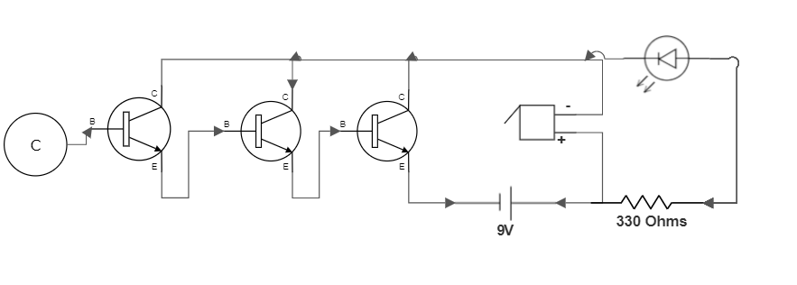

02

**Chapter 3**

**Materials Required**

1. **3 NPN (BC 547) Transistor -**

BC547 is a bipolar junction transistor (BJT). It is kind of an NPN transistor. It has three terminals: Emitter, Collector and Base.

The maximum current gain of BC547 is 800A. BC547 is usually used for

current amplifier, quick switching, and pulse-width modulation (PWM).

Therefore, if you need to control the speed of a motor or actuator in some of your projects, you can simply use this transistor to achieve it. In addition, it can also be used as a switch that you can easily switch on or off a DC device with this transistor.

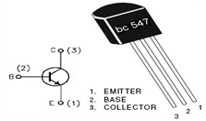

**Fig 3.1: BC547 Transistor**

03

1. **LED -**

A light-emitting diode (LED) is a semiconductor light source that emits light when current flows through it. Electrons in the semiconductor recombine with electron holes, releasing energy in the form of photons. The color of the light (corresponding to the energy of the photons) is determined by the energy required for electrons to cross the band gap of the semiconductor White light is obtained by using multiple semiconductors or a layer of light-emitting phosphor on the semiconductor device.

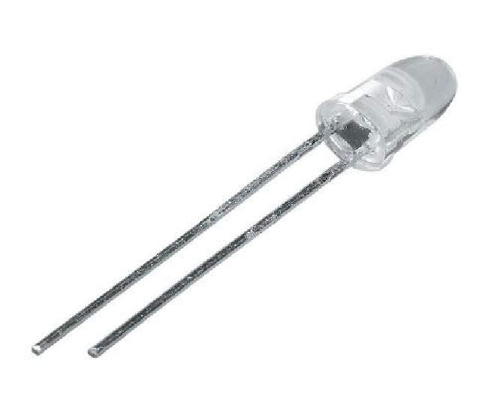

**Fig 3.2: LED**

1. **Buzzer –**

A buzzer or beeper is an audio signaling device, which may be mechanical, electromechanical, or piezoelectric (piezo for short). Typical uses of buzzers and beepers include alarm devices, timers, and confirmation of user input such as a mouse click or keystroke.

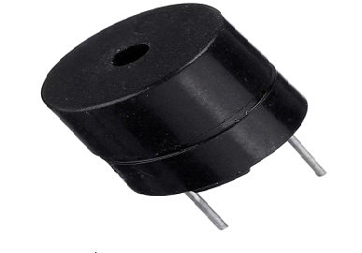

**Fig 3.3: Buzzer**

04

1. **PCB -**

PCB or Printed Circuit Board is the traditional name for the bare board of which you supply us with the layout data and which you use to mount your components on once we have delivered it to you.

A printed circuit board, or PCB, is used to mechanically support and electrically connect electronic components using conductive pathways, tracks or signal traces etched from copper sheets laminated onto a non-conductive substrate.

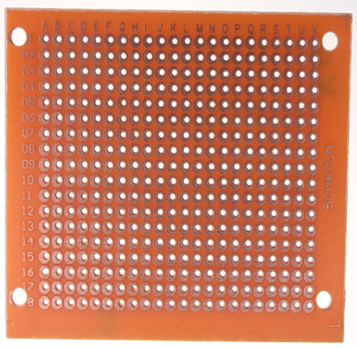

**Fig 3.4: PCB**

1. **Copper coil –**

This will be connected to the base of the first transistor of the Darlington pair, which world act like a plate of a capacitor with earth as the reference (another plate of the capacitor). Thus, there will be some capacitance between the two, due to which the coil will receive signal and the transistor will eventually amplify the signal.



**Fig 3.5: Copper Coil**

05

1. **9v battery –**

Which would be connected to light up the led and ring the buzzer when the copper coil detects any current. A 330-ohm resistor will also be connected in series with the LED to only allow the required amount of current to flow in the LED to glow.

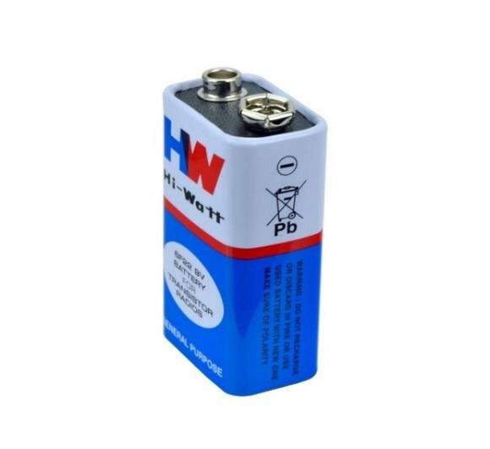

**Fig 3.5: Copper Coil**

06

**Chapter 4**

**Working**

A magnetic field is produced around a current carrying conductor and if current through the conductor is alternating current (AC), the magnetic field produced varies periodically. A non-contact AC voltage detector detects the changing magnetic field around AC energized objects.

This non-contact AC voltage detector uses NPN type transistors in order to detect voltage. A transistor has three terminals - collector, emitter, and base. Collector to emitter current is controlled by the base current. When there is no base current, no collector to emitter current flows. Thus, a transistor acts as a switch. It can be 'ON', it can be OFF or in-between.

The ratio of collector current to base current is known as the gain of a transistor. The maximum gain of BC547 is about 800, i.e., collector to emitter current can be as high as 800 times the base current. If we connect the output of one transistor to the base of another transistor, the total gain would be multiplication of the two i.e., 800x800=640000. Thus, if we connect three transistors in such configuration, the total gain would be 800x800x800 = 512,000,000. Therefore, an extremely small signal can be used to switch ON a normal circuit by using such configuration of transistors.

In our circuit, an antenna (copper wire) is connected to the base of first transistor. When we place this antenna near an object that is AC energized, a small current gets induced into the antenna due to electromagnetic induction. This current trigger the first transistor and output of the first transistor triggers the second and third. The third transistor switches ON the LED and buzzer circuit, indicating that AC voltage is present.

07

**Chapter 5**

**Advantages -**

* + The Leakage can be detected by using a wireless AC Line detector which will help to prevent accidents.
  + In industries accidents takes place due to leakage of electricity. The accidents can be avoided by using the wireless AC Line detector.
  + The motive of this project is to detect presence of electricity wirelessly.

08

**Disadvantages -**

* The tester will NOT detect voltage if the wire is shielded, the operator is not grounded or is otherwise isolated from effective earth ground, if sheathed NM cable is saturated, or the voltage is DC.
* The tester MAY NOT detect voltage if the user is not holding the tester, the user is insulated with a glove or other material, the wire is partially buried or in a grounded metal conduit, the tester is at a distance from the voltage source, or if the field created by the voltage source is being blocked or interfered with.

09

**Applications –**

* + A non-contact voltage tester or detector is an electrical tester that helps to detect the presence of voltage. Voltage presence is useful information to have when troubleshooting or working on a failed asset. The first tool you'll reach for is a non-contact voltage detector.
  + Voltage detectors are a quick, inexpensive way to check for the presence of live voltage on ac circuits, switches and outlets before working on them.

10

**Chapter 6**

**Result**

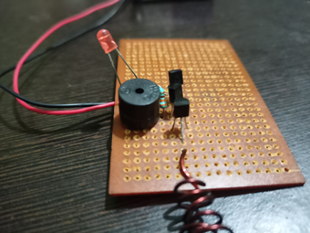

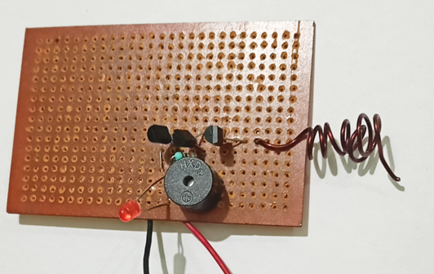

**Fig 6.1: Sample figure**

11

**Chapter 7**

**Conclusion**

* Non-contact AC voltage detectors are a quick, inexpensive way to check for the presence of live voltage on ac circuits, switches, and outlets before working on them.
* Voltage presence is useful information to have when troubleshooting or working on a failed asset. The first tool you'll reach for is a non-contact voltage detector.

12

**Chapter 8**

**Future Scope**

* We can add a sensor to the circuit to detect and to display the current value that is flowing in the current carrying conductor.
* We can also increase the number of NPN transistor in the darlington configuration to increase its amplification property drastically or we can increase the surface area of the copper coil by attaching a aluminum foil that way current can be induced more fastly and effectively in the copper coil thus increasing its sensitivity

13

**References -**

* <https://youtu.be/5F6NWmSjZz0>
* <https://www.jameco.com/Jameco/workshop/JamecoFavorites/non-contact-AC-voltage-detector.html>
* <https://www.electronicshub.org>
* <https://www.wikipedia.org/>
* Electronics Devices and Circuit Theory (Robert L. Boylestad)

12

14